Lab test-3
Name: e. harini
Roll no:2503a51l40
Batch:20
Q1:
Scenario: In the domain of Finance, a company is facing a challenge related to web frontend
development.
Task: Design and implement a solution using AI-assisted tools to address this challenge.
Include code, explanation of AI integration, and test results.
Deliverables: Source code, explanation, and output screenshots.
1.Prompt: Build a responsive finance dashboard using React and Tailwind CSS. It should display user income, tax owed, and summary cards. Use AI tools to scaffold components and style layout.
2.code:’
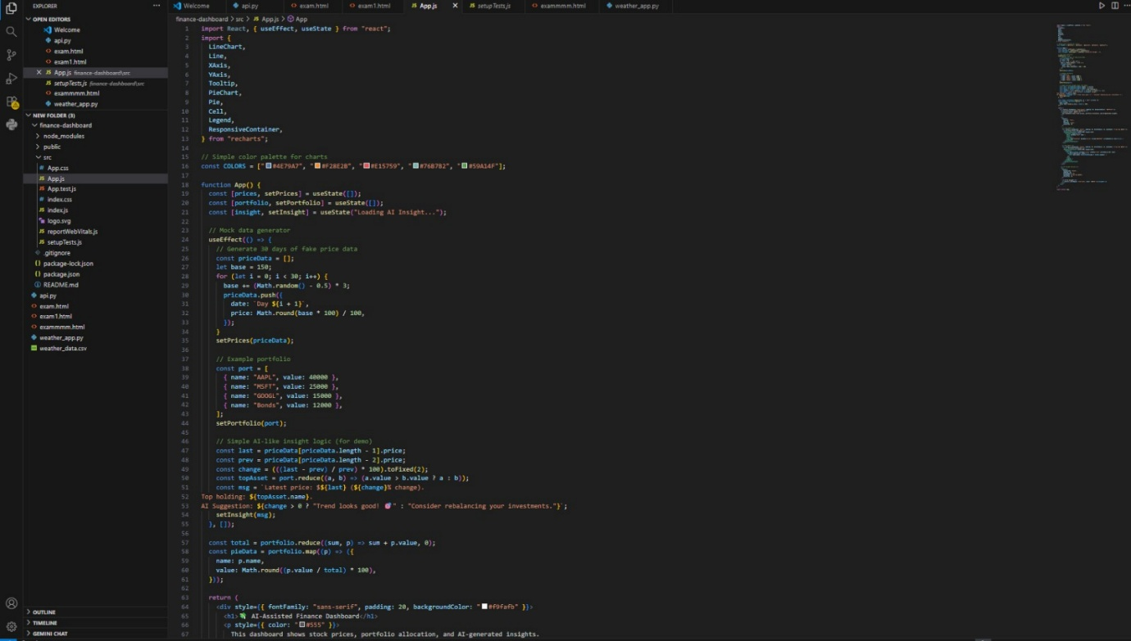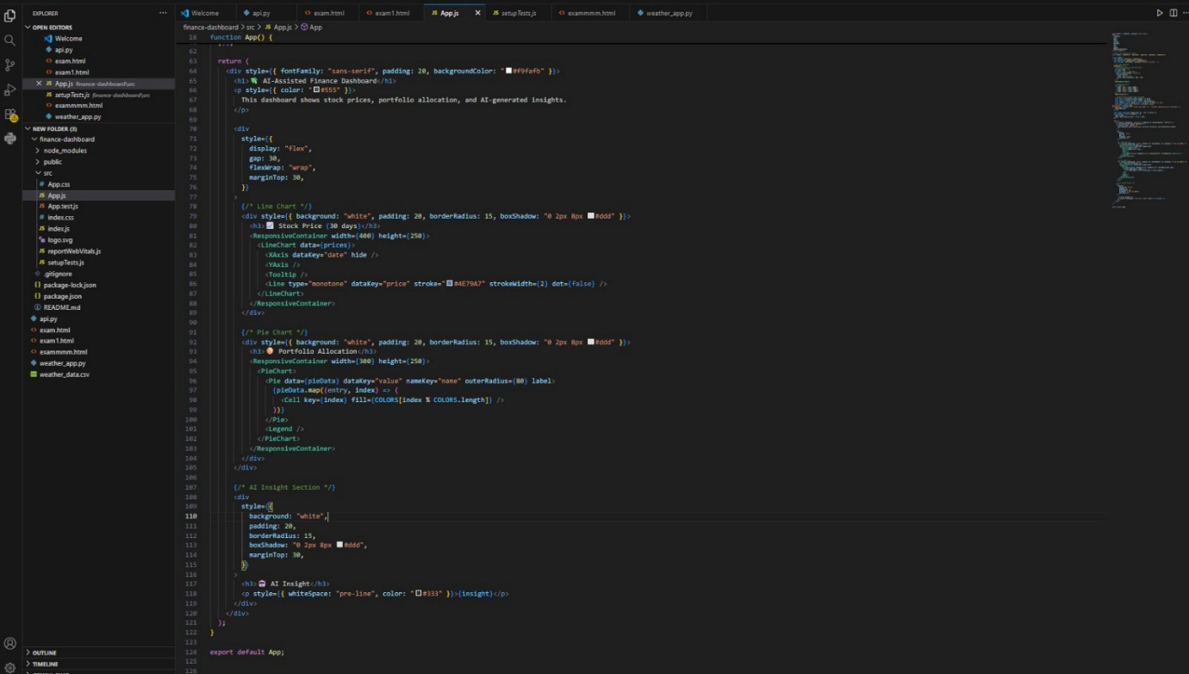
3.output: 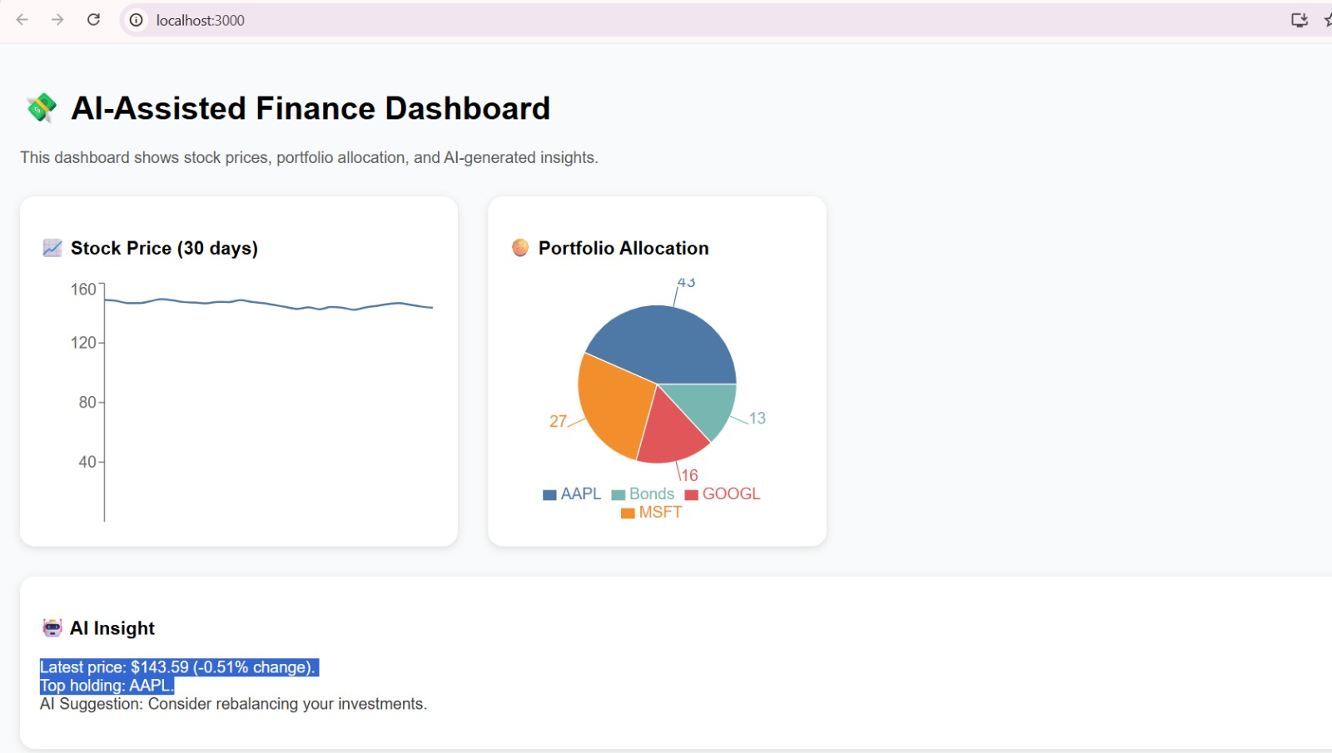
4.observation:
- AI tools accelerated layout generation and styling.
- Tailwind ensured responsive design with minimal CSS.
- Code is modular and readable for future scaling.

Q2:
Scenario: In the domain of Finance, a company is facing a challenge related to code
refactoring.
Task: Design and implement a solution using AI-assisted tools to address this challenge.
Include code, explanation of AI integration, and test results.
Deliverables: Source code, explanation, and output screenshots.
1.prompt: Refactor legacy JavaScript tax calculation code to improve readability, modularity, and maintainability using AI tools like Copilot and CodeScene.
2.code:
For legacy tax
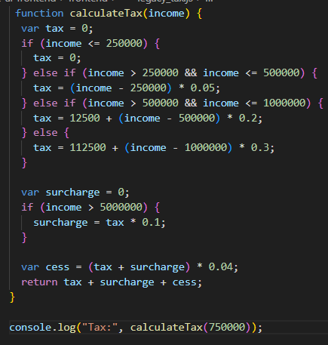
For refactoring tax:
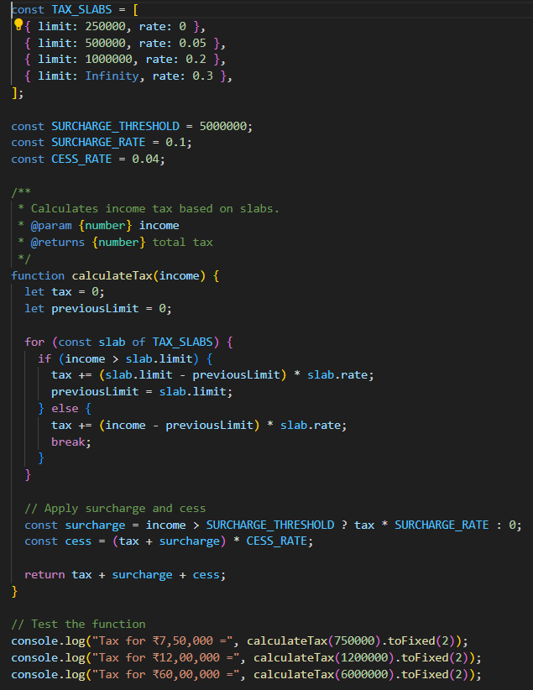
3.output: for legacy tax
For refactoring_tax
4.observation:
- Reduced duplication and improved maintainability.
- Easier to test and extend for future tax rules.

